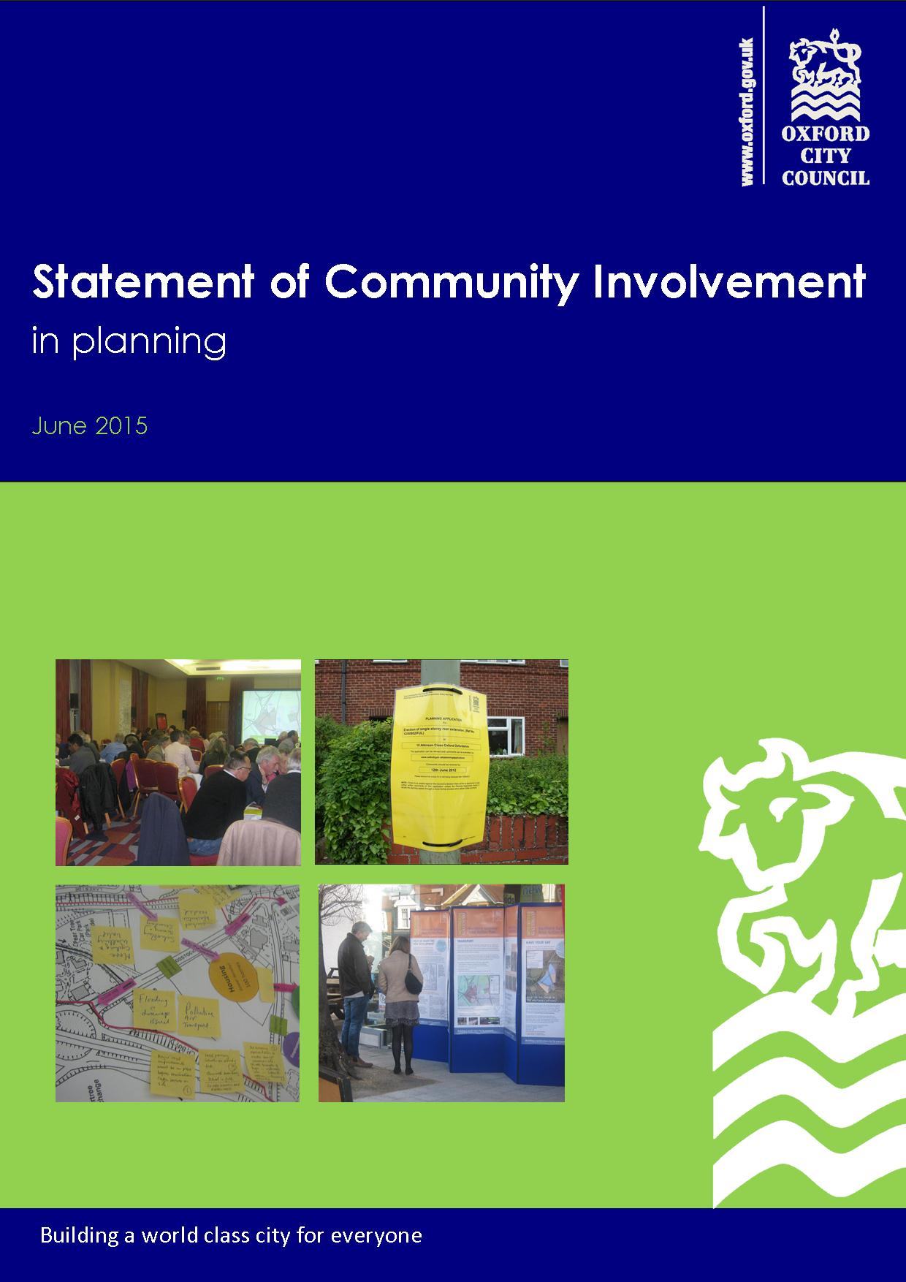

Contents

1. Introduction 3
What is the Statement of Community Involvement in Planning? 4
Oxford’s communities 4
2. Our principles for community involvement in planning decisions 5
Why is it important to involve the community in the planning process? 5
Our principles for community involvement in planning decisions 5
3. Engagement processes for planning policy documents 8
Which documents will we be consulting on? 8
How will we involve people in the preparation of planning policy documents? 10
Consultation on Development Plan Documents 10
Consultation on Supplementary Planning Documents (SPDs) 12
Keeping you updated throughout the planning policy preparation process 12
4. Consultation process for Neighbourhood Development Plans 14
5. Engagement processes for planning applications 16
Consultations before planning applications are submitted to the City Council 16
Involvement once applications are submitted and are under consideration by the City Council 17
How planning applications are determined 18
Appeals against planning application decisions 19
6. How will consultations be resourced? 21
Appendices 22
Table 1: Summary of statutory requirements and additional consultation methods for Development Plan Documents 23
Table 2: Summary of statutory requirements and additional consultation methods for Supplementary Planning Documents 25
Table 3: Summary of Planning Application Consultation 27

1. Introduction

  - It is an aim of the City Council to improve dialogue and consultation throughout Council processes.

  - This is explained in the Corporate Plan 2015-2019, and then over-arching principles and actions are set out in the Community Engagement Policy Statement 2014-2017. The City Council has also produced the Corporate Equality Scheme 2012-2015, which identifies that having fair access to engage in the planning process is a priority for the City Council. These strategies apply to all the City Council’s services and are not specific to the planning process.

  - There is then an additional legal requirement under the Planning and Compulsory Purchase Act 2004 (as amended) for the City Council to produce a Statement of Community Involvement (SCI), which sets out how it intends to achieve community involvement in the preparation of plans and in decision-making on planning applications.

  - The City Council adopted its first SCI in 2006. Since then there have been a number of changes to the planning system which have produced new requirements and processes for producing local plans and for dealing with planning applications.

  - In addition, the City Council is keen to promote earlier public engagement in planning decisions. The City Council continues to keep these processes under review, including commissioning an independent review of planning processes, including consultation processes, through the Roger Dudman Way Review (2013). The recommendations and lessons learnt about community engagement from these reviews have also helped to shape this Statement of Community Involvement (in Planning) (SCIP).

  - The SCIP sets out consultation requirements and guiding principles, with more detailed information provided through supplementary guidance and help sheets that can be updated more easily and frequently via the website. This is so that the SCIP is flexible if there are further changes to the planning regulations or government policies in the next few years, and so that we can adapt processes to reflect best practice.

  - The SCIP goes above the minimum statutory requirements for consultation and promotes best practice in the delivery of our planning services.

What is the Statement of Community Involvement in Planning?

  - Oxford City Council is the local planning authority for Oxford. The SCIP sets out the City Council’s approach to involving the community and stakeholders in the production of planning policy documents and planning control decisions in the city.
The Statement of Community Involvement sets out how the City Council will involve the community when preparing planning policy documents and deciding on planning applications.

The Statement of Community Involvement:
- Lets you know how you can get involved in planning decisions;
- Sets out how we will engage the wider community in planning decisions; and
- Sets out the level of community engagement that we expect from developers in the planning process.

In summary, it is about how we inform, involve and consult local people in our planning decisions.

  - In preparing the SCIP, consultation has been undertaken to help develop an approach that reflects the needs and aspirations of the community, stakeholders and the City Council.

Oxford’s communities

  - The ‘community’ includes all the individuals, groups and organisations that live, work, or operate within Oxford. Communities can take many forms, they can be:

- Communities of Place - people living, working or undertaking other activities in geographically distinct areas of the city (such as neighbourhoods or wards).

- Communities of Identity - people who share common aspects of their identity (such as ethnicity, religious beliefs, age or gender).

- Communities of Interest - people with shared interests (such as allotment holders, cyclists or businesses) or people who use the same services or facilities (such as parks, roads, or community buildings).

  - The SCIP also refers to ‘stakeholders’. By this we mean individuals or organisations with a direct influence on the subject under discussion, such as landowners or the highways authority. Some of our consultation with stakeholders is also governed by legislation such as the Duty to Cooperate. The SCIP seeks to avoid repeating legislation or statutory requirements, because that is fixed by the government. Instead it focusses on what we are specifically doing locally in Oxford over and above the requirements.

2. Our principles for community involvement in planning decisions

Why is it important to involve the community in the planning process?

  - We want to inform and involve the community in planning decision-making processes. Achieving effective community involvement in the planning process can have several benefits, including:

- More focus on the priorities identified by the community;
- Influencing the provision of local services to meet local needs;
- Ability to draw upon a local knowledge base;
- Increased community commitment to the future of an area; and
- Increased support for planning services, as communities will have a better understanding of how planning policies are developed and how decisions are made.

  - The City Council’s approach to community engagement contributes directly to its ambition to build a world class city for all. Many of Oxford’s residents are highly articulate and very skilled at getting their points of view heard and those contributions are always welcome. The City Council also wants to open up more opportunities for people whose voices might not be so easily heard to be involved if they wish to.

Our principles for community involvement in planning decisions

  - The commitments in this SCIP are framed by wider City Council strategies about community engagement, as well as being informed by consultation and other feedback.

  - The following general principles for community engagement were agreed in the City Council’s Community Engagement Policy Statement 2014-2017:

- Flexibility
- Proportionality
- Transparency and clarity
- Timeliness
- Feedback
- Inclusiveness and accessibility

  - In addition we have identified four key principles for effective engagement in planning processes:

      - Timely and sustained – events and activities should start before any planning decisions are made and engagement should last throughout the planning process and beyond;

      - Inclusive for all local people – those living and working in an area have a right to be involved, all parties are welcome, and process must take account of peoples’ varied needs;

      - Two way, open and responsive – communication should be discursive not prescriptive, so that information can be debated and ideas exchanged; and
      - A matter of public record – the processes must be documented and published.

(Roger Dudman Way Review 2013, paragraph 91)

  - The SCIP has also been informed by consultation and reviewing customer feedback. Two of the key themes that came out is that people want to be involved at an early enough stage when decisions and proposals can still be truly influenced, and also to be kept informed of progress and for us to set out more clearly how consultation has influenced decisions so that people can see how it has followed through the process.

  - Therefore a general theme of the SCIP is that consultation should start as early as possible to give everyone the opportunity to participate and influence the development of policies and options for an area. This includes encouraging consultation on major applications at an early stage. This will give communities and stakeholders the chance to put forward their own ideas rather than simply comment once proposals are fixed. The City Council and applicants will then be better placed to understand the issues and needs that are important to the community.

  - It also encourages on-going community involvement, with feedback and information on progress and outcomes. Involving communities at an early stage, and continuing that involvement throughout the planning process, will help to resolve issues and achieve consensus where possible, which will in turn avoid the need for lengthy independent examinations. Nonetheless planning decisions are often contentious, and require differing views (including those of the community) to be balanced and judgements made. So the SCIP also promotes transparency of processes and decisions, and clearer communication, so that even if people do not like the outcome of a decision they can at least understand how it has been reached.

  - The scale and type of community involvement in planning also needs to be proportionate and appropriate, and reasonable in terms of cost.

Based on these principles, this SCIP seeks to ensure the planning service provides:

The opportunity to contribute ideas – people will have the opportunity to put their ideas forward and the City Council will consider and respond to these suggestions as appropriate;

The opportunity to shape proposals and options – the City Council will provide opportunities for people to actively engage in the planning process at early stages when there is more scope to shape them. The City Council will also encourage applicants/the promoters of development proposals to do the same;

The opportunity to make comments on formal proposals – for more advanced development proposals and planning policy documents, the City Council will meet the Regulatory requirements for community involvement, and where appropriate go beyond the requirements;

The opportunity to receive feedback and be informed about progress and outcomes –the City Council will consider all comments received through consultations on policies, and make appropriate changes accordingly and explain our response. The City Council will then provide updates on the progress of planning policy documents to all those who have submitted comments on the document. This may be by direct contact or by publishing material on the City Council’s website (e.g. consultation reports and updates).

The City Council will also explain how comments on planning applications have been taken into consideration in officer’s reports. These reports are published on the City Council’s website; and

To provide relevant information - when asking for comments, the City Council will be clear about which issues can and cannot be taken into consideration, which issues are already fixed (eg by legislation);

To achieve value for money – ensuring consultation is worthwhile and value for money by balancing cost and time constraints and City Council resources, and ensuring that consultation is appropriate and proportionate to the issues being considered and the communities affected.

We will deliver these principles through:

- Being open and transparent in our decision-making;
- Using plain English as far as possible;
- Ensuring that planning policy documents are clear and concise;
- Using images, maps and illustrations, to make planning policy documents more accessible to a wider range of people;
- Front-loading engagement at the early stages of producing new policies and generating options;
- Encouraging developers to undertake early consultation when preparing planning applications, including before they are submitted as formal applications;
- Promoting electronic methods of communication to increase efficiency (whilst also providing for those who find it difficult to access material online); and
- Promote best practice, and explore new and evolving methods of communication and consultation.

  - The rest of this document and appendices explain how these principles will be applied to the preparation of policy documents and consideration of planning applications.

3. Engagement processes for planning policy documents

Which documents will we be consulting on?

  - The main planning policy documents that the City Council produces are:

Statement of Community Involvement – this document is itself the subject of public consultation to help develop an approach that reflects the needs and aspirations of the community, stakeholders and the City Council. The consultation requirements set out in this document will need to be met in producing any new local development plan documents or supplementary planning documents.

Local Development Scheme – this sets out the City Council’s programme for creating new development plan documents and supplementary planning documents over a three year period, including a description and timetable for each document. The Local Development Scheme is published on the City Council’s website.

Local Plan – this may consist of several development plan documents, including:
- Core Strategy (or Local Plan) – this outlines the vision for the city and how it will be achieved. Also includes development management policies, or these may be in a separate local plan document;
- Site Allocations – this allocates land for specific uses; and
- Area Action Plans – these provide more detailed information to guide development in a specific area where significant development is planned.

Supplementary Planning Documents – these documents supplement and elaborate upon policies and proposals set out in development plan documents. Although they are not subject to independent examination, they will undergo public consultation, and must be consistent with national planning policies. These documents may focus on specific issues (such as affordable housing) or they may provide site specific development guidance. They cannot change policies contained within the Local Plan or Neighbourhood Plans, but can give detail on how those policies are implemented.

Sustainability Appraisals – these will be produced by the City Council alongside local development plan documents and, where appropriate, supplementary planning documents. Sustainability Appraisals examine the impact of policies and proposals on economic, social and environmental factors, and fulfil an important legal requirement known as ‘Strategic Environmental Assessment’). Sustainability Appraisals are iterative, prepared alongside policy documents, and will be available for consultation alongside the development plan documents or supplementary planning documents that they relate to at formal stages of consultation.

Annual Monitoring Report – the performance of planning policies will be reviewed in an Annual Monitoring Report. The Annual Monitoring Report will also review the implementation of the Local Development Scheme and Statement of Community Involvement in Planning. There will not be consultation on this report as it is a factual document, but we may contact specific groups to obtain some of the data required.

  - Figure 1 over the page explains how the different planning policy documents link together to form the Local Plan for Oxford and their relationship with the wider planning process.

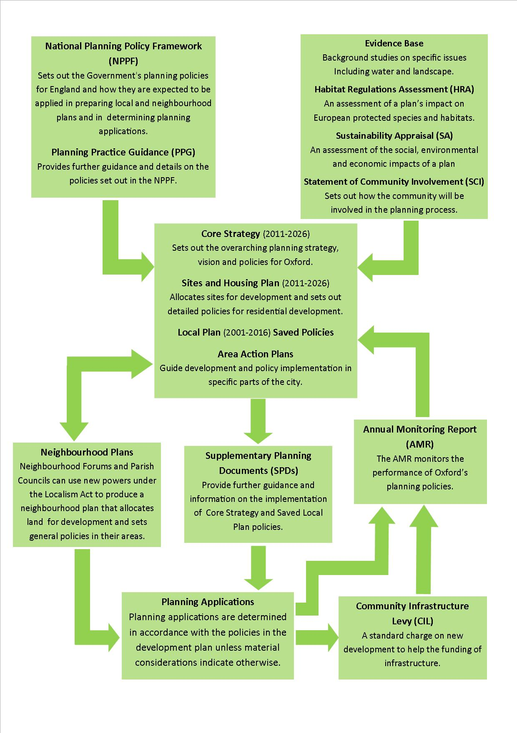
Figure 1: Oxford’s Local Plan and its relationship to the wider planning process

How will we involve people in the preparation of planning policy documents?

  - There are a range of different methods of involvement that we may use in preparing planning policy documents (as set out in Appendices Tables 1 and 2). The methods we use will depend on the subject and the stage in the plan-making process.

  - Different levels of involvement that may be appropriate in different circumstances:

- Participation – interactions between the City Council and the community and/or stakeholders to identify issues and exchange views (for example, when considering the issues a policy document might need to address);

- Consultation - asking for the views of the community and stakeholders (for example, asking for views on a draft document); and

- Information-sharing - providing information to the community and stakeholders (for example, providing updates on the progress of planning policy documents).

  - Sometimes it will be more appropriate to gather a wider-range of less detailed comments using methods such as questionnaires and surveys. This is often a good way to collect views from a large number of people, although it does not generally provide much opportunity for an in-depth discussion of the issues.

  - At other times we will need to talk to people in more detail, such as through workshops or meetings with specific groups, to gain a deeper understanding of their views. When undertaking consultation on planning policy documents, we will aim to use a variety of methods to reflect the topic matters and to try to reach the different community groups that may be affected.

  - We will continue to look to best practice examples in this evolving field.

Consultation on Development Plan Documents

  - The key stages that the City Council will follow in preparing the Local Plan (which may consist of several development plan documents) are largely set out in legislation and national policy, but the SCIP sets out in more detail what we will do in Oxford and how we are going beyond the basic requirements. The process is different for Neighbourhood Plans and Supplementary Planning Documents, which are explained later in this SCIP.

  - The key stages for Development Plan Documents are:

1. Establish an appropriate consultation programme for each document - When starting work on any new development plan document, the authorising City Council body will agree a bespoke consultation programme for that document. This will set out which communication and consultation methods are most appropriate for that document and how they will be used at each stage, so that both councillors and the public are clear about what consultation can be expected from the start. This tailored consultation programme will be published and will then be followed throughout the process of preparing the document.

Whilst this stage is not required by the Regulations, the City Council is adopting this approach to ensure that consultations can be tailored appropriately and proportionately to the issues and the community groups that may be affected. Table 1 in the Appendices provides more information on the methods of communication and consultation that may be used.

2. Early community and stakeholder involvement – Before policy writing begins, informal consultation will be undertaken and a process of informal dialogue will commence. This may be as wide-ranging as simply asking questions about what the document and policies should include.

The main purpose of this stage is information-gathering. This stage enables people to put forward their ideas and to participate in the initial stages of developing proposals and options whilst the discussion is still fairly broad. Once we are sure that we have understood and considered all the views expressed we will start to refine this and narrow it down, to formulate options and proposals, including input, as appropriate, by City Council bodies.

3. Consultation on the emerging options or draft policies (as applicable) – As part of the process of refining the options and policies, the City Council may publish an options document and/or a draft policies document, including a related Sustainability Appraisal, for public comment. Any formal consultation will normally last for six weeks. There is also likely to be informal dialogue through this period, as appropriate.

4. Pre-submission consultation– When the City Council has refined the policies to what it thinks is the final version, it will publish the document for a final stage of consultation before submitting it to the Government. Normally at this stage the key evidence documents that sit behind the plan/policies will also be made available including the Sustainability Appraisal. Consultation will normally last for six weeks.

Following this consultation, the City Council will normally only make minor changes to the document, such as to clarify text. The City Council will collate the comments received and pass them to the Government Inspector to consider along with all of the other supporting documents and comments from earlier stages of consultation.

5. Independent examination – This will be held by an independent Inspector (appointed by the Government). The examination process is determined by the Inspector so it is not for the City Council to propose a process for this stage in the SCIP, or to replicate what is already set out in government guidance or regulations elsewhere. The examination period commences once the document has been submitted to the Government and ends when the Inspector issues their report or conclusions. Within this period there are usually hearing sessions, where people who have commented at the pre-submission stage may be invited by the Inspector to speak in a round-table discussion.

6. Adoption – The final stage is for the City Council to adopt the document. The decision will usually be made by Full Council, and published on the Council website. It is at this point that the document formally becomes part of the Local Plan, and can be fully applied to relevant planning decisions.

Consultation on Supplementary Planning Documents (SPDs)

  - The key stages in preparing SPDs are slightly different to those for development plan documents because they normally provide supplementary guidance rather than policies, as set out below:

1. Establish an appropriate consultation programme - When starting work on any new supplementary planning document, the authorising City Council committee will agree a bespoke consultation programme for that document. This will set out the details of which communication and consultation methods are most appropriate for that document and how they will be used at each stage, so that both councillors and the public are clear about what consultation can be expected from the start. This consultation programme will then be followed throughout the process of preparing the document.

Whilst this is not required through the Regulations, the City Council is adopting this approach to ensure that consultations can be tailored appropriately and proportionately to the issues and the community groups that may be affected. Table 2 in the Appendices provides more information of the methods of communication and consultation that may be used.

2. Early community and stakeholder involvement –The main purpose of this stage of involvement is information gathering. This may be as wide-ranging as simply asking questions about what the document should include or the approach it should take, or it may be more focused on specific issues and options. Consultation may be focused on those with specific expertise in the subject area, like developers or highway engineers, or on people living and working in a specific geographical area.

A Sustainability Appraisal will be produced where appropriate but is not always required for SPDs, depending on the topic.

3. Consultation on the emerging draft – As with development plan documents, we will usually publish a draft document for formal consultation for six weeks. We will consider all the comments received and will refine and finalise the document before progressing to adoption. Unlike development plan documents, there is no examination process for SPDs.

4. Adoption – The document, together with an analysis of comments received (as applicable), will be reported through City Council committees if appropriate. It will normally be adopted by the City Executive Board and published on the City Council website. It is at this point that the SPD will hold full weight as a ‘material consideration’ in relevant planning decisions.

Keeping you updated throughout the planning policy preparation process

  - Throughout the process of preparing development plan documents and supplementary planning documents, from the earliest stages through to adoption, we will keep the community and stakeholders informed of progress in the following ways:

- The latest version of any formally published consultation documents will be available on the City Council website and at relevant deposit points throughout the city;
- The City Council will acknowledge representations received by electronic means (email or online forms) at each consultation stage;
- Reports to City Council committees (including City Executive Board and Full Council) are available on the City Council website and these meetings are held in public;
- At examination stage (for local development plan documents), we will tell those who asked to be notified when the document has been submitted to the Secretary of State. We will also publish a consultation summary report on the City Council website and the representations from the pre-submission stage will be made available for public inspection;
- The final, adopted versions of documents will be published on the City Council website and at relevant deposit points throughout the city; and
- Throughout the preparation of the plan, an email address and contact phone number will be available for the community and stakeholders to find out the current position on the progress of documents, in addition to the information that will be supplied on the City Council website.

4. Consultation process for Neighbourhood Development Plans

  - As well as formal consultation comments to inform the SCIP, the Council has also reflected on previous consultation experiences, from the perspective of the customer and of the Council. Recent policy document

  - The preparation of neighbourhood planning documents is led by local communities in accordance with the Regulations and the principles of localism. As such, the majority of the community engagement in the preparation of Neighbourhood Plans will be undertaken by the neighbourhood planning group.

  - There are then certain stages where the City Council is required to carry out formal consultation in accordance with the Regulations as follows:

- Application to designate a Neighbourhood Area
If a community wishes to produce a Neighbourhood Plan then the first stage is for the area to be designated. The City Council will publish the name of the neighbourhood area, a map, and the name of the relevant body who applied for the designation on the City Council website. People will be able to comment on the extent of the area to be designated. In addition, the neighbourhood planning group will be encouraged to let the local community know through local notices, their own websites, and other means as appropriate.

Following this consultation, the City Council will publish its decision to either designate or refuse the application (with reasons, if refusing) on the City Council website.

- Application to designate a Neighbourhood Planning Group
The City Council will publish a copy of the application and details about how to comment, on the City Council website. The City Council will also encourage the neighbourhood planning group to publicise the application in the local area.

If the City Council agrees to designate the group, it will publish the name of the group, a copy of the constitution, and contact details on the City Council website. If the City Council decides to refuse the designation then it will publish reasons for the refusal on the City Council website.

- Options testing and preparing the Neighbourhood Plan
(Consultation carried out by the neighbourhood planning group)
During the preparation of their plan, the neighbourhood planning group will need to carry out consultation on the issues and options being considered, and involve the local community. They will be encouraged by the City Council to engage as early as possible, and to take into account emerging best practice in this relatively new, and still evolving, area of planning policy. They may also need to prepare a Sustainability Appraisal and consult on that as well.

- Pre-submission consultation
(Consultation carried out by the neighbourhood planning group)
At this final stage of consultation, before the plan is submitted to the City Council, the neighbourhood planning group will be encouraged to take into account emerging best practice.

- Publicity/submission consultation
Once the neighbourhood planning group has submitted their Neighbourhood Plan to the City Council, the City Council will publish the plan and supporting documents in accordance with the regulatory requirements on the City Council website. Copies of these documents will also be available at the main council offices (St Aldate’s Chambers). The City Council will contact all those who we are advised have commented previously on the Neighbourhood Plan to invite final comments.

- Decision on a Neighbourhood Plan
The City Council will send a copy of the Neighbourhood Plan, the supporting documents and comments received at the submission stage to an appointed examiner for independent examination. Hearing sessions, if required (at the discretion of the Examiner), will be open to the public to attend but only those invited by the Examiner may participate in discussions.

The City Council will then publish the Examiner’s report and decision statement on the City Council website, and make it available to view at the City Council’s main offices (St Aldate’s Chambers), before proceeding to arrange (subject to a favourable Examiner’s report) the referendum.

- Referendum
At least 28 days before the referendum takes place, the City Council will publish the following documents on its website (hard copies will also be made available at the main City Council offices, St Aldate’s Chambers): the draft Neighbourhood Plan; the Examiner’s report; a summary of the representations submitted to the Examiner; a statement that the City Council is satisfied that the plan meets the basic conditions; general information on town and country planning to ensure voters have sufficient knowledge to make an informed decision; and an information statement that provides detailed information on the referendum arrangements. The City Council will also encourage the neighbourhood planning group to let local people know about the referendum and encourage a high participation rate so that it is representative.

The Regulations cover all aspects of organising and conducting a referendum, so it is not for the City Council to propose processes in the SCIP, or to replicate what is already set out in government guidance or regulations elsewhere. If the majority of those who vote in a referendum are in favour of the draft Neighbourhood Plan, then the Neighbourhood Plan becomes part of the statutory development plan for the area. As such, it will then steer relevant planning decisions for that area of the city.

5. Engagement processes for planning applications

  - The degree of involvement in planning applications will vary according to the nature of the individual application, and at different stages. The processes are different to those for policies, because usually there is a role both for the applicant as well as the City Council, especially on larger applications.

Consultations before planning applications are submitted to the City Council

  - All applicants (or their agents) are strongly encouraged to discuss development proposals with the City Council before applying for planning permission. Applicants are also encouraged, especially for major applications, to engage with the community and relevant stakeholders, to a degree proportionate to the nature of the proposal, at the earliest appropriate opportunity.

For minor applications (such as house extensions), all applicants are encouraged to discuss their plans with their neighbours before submitting a planning application. This could involve speaking with them or putting a note through the door.

If the scheme falls within the definition of a ‘major’ application then applicants are strongly encouraged to contact those who live, work and/or undertake other activities in the surrounding area who may be affected by the proposals, to inform them of their plans and to identify/discuss any potential issues and opportunities so that the submitted proposal acknowledges and addresses community concerns, even if it cannot fully resolve them. Consultation at this stage should be appropriate and proportionate, and will normally include helping the community and non-planning experts to visualise what the development will look like and to understand the impacts on the area.

Whilst there is no legal obligation for applicants to undertake consultation at the pre-application stage, failure to consult properly is likely to lead to objections being made by interested parties (such as neighbouring residents) later on in the process which could be material to the determination of a planning application. Pre-application consultation may be made a formal requirement via a Planning Performance Agreement where relevant.

A statement setting out how consultation has been carried out and any changes made to the proposals as a result, is encouraged to be submitted with the planning application, and should be easy for the community to find so that they can easily see the feedback. Developers are also encouraged to feedback directly to the community via a second round of pre-application engagement, before submitting the application to the Council, to explain any changes to the proposal and how concerns have been addressed.

We also encourage applicants to let the local ward councillors know about their proposals. The City Council’s Code of Practice for councillors on planning applications advises that councillors attending public meetings should take great care to maintain their impartial role, listen to all the points of view expressed by the speakers and public, and not state a conclusive decision on any pre-application proposals or submitted planning applications. Nonetheless we would encourage applicants on major schemes to make local councillors aware of their proposals so that they can help to bring it to the attention of their constituents at the earliest stages.

Similarly, applicants are encouraged to contact local representative groups who may be able to help raise awareness and explain the proposals to the community, and may also be able to provide representative views from a community perspective and provide local insight.

  - There are significant benefits to involving communities and stakeholders early on in the process of preparing of a proposal before it is finalised and submitted to the City Council for planning permission, including:

- Issues and opportunities can be identified, and where possible addressed, early on in the process, making more efficient use of resources (both for the applicant and the City Council);
- Community and stakeholder views can be taken into consideration early on, helping to achieve higher quality design that utilises local knowledge and better reflects communities’ needs and aspirations;
- Addressing issues early on is likely to result in higher quality proposals that are likely to move through the application process more quickly and smoothly;
- Responding to community and stakeholder views early on reduces the likelihood of objections at the application stage; and
- Early engagement increases openness and transparency.

  - With regard to major applications, it is noted that Section 122 of the Localism Act 2011 currently requires applicants to carry out pre-application consultations where a proposed development meets criteria set out by the Government in a development order. In future there may be additional development orders published in relation to this requirement, which will influence the requirements for applicants to consult on major applications. Irrespective of the regulations, the City Council is keen to encourage pre-application engagement.

Involvement once applications are submitted and are under consideration by the City Council

  - The Government sets out minimum standards for consulting on planning applications that the City Council must comply with (see Appendices Table 3). These standards apply to all applications. If the City Council goes beyond the standards required by the Government then there needs to be a balance between cost, speed of decision making, and providing a reasonable opportunity for public comment.

  - People are encouraged to ‘self service’ where possible, using updates on the City Council website and through alert services such as PlanningFinder to find out about planning applications.

  - The City Council will make information available about planning applications using the following methods (underlined indicates online/electronic information):

Advertisements and site notices – site notices will be placed in the vicinity of the application site to notify the occupiers of the properties most likely to be affected by the development proposals, including those bordering an application site. The number and location of notices will be proportionate to the proposal. Comments are normally required within five weeks of the notice being displayed. Developers are also required to display site notices for certain types of development. In addition, the City Council is required to publish information about some types of planning application in a local newspaper.

Public Access – the details of all submitted planning applications are available on the City Council website to view online through the Public Access system.

PlanningFinder – online tool similar to Public Access which enables the public to view all planning applications. People can also register to receive email updates about individual applications or notifications of new planning applications received within specific postcode areas to help you find out about development in an area.

Weekly list – a list is published weekly of all the valid planning applications we have received. This list also highlights key information such as developments in or affecting conservation areas and developments that could affect a listed building or its setting. The list is available on the City Council website.

Statutory consultees – we are legally required to consult certain organisations as set out in government guidance. The organisations consulted will vary depending on the nature of the proposal and location.

Availability of plans – plans and documents submitted as part of a planning application are available to view online at the main City Council offices (St Aldate’s Chambers) during office hours. Paper copies of documents for major planning applications are available in reception, or for other types of planning application are available to view by making an appointment with the relevant case officer in advance. All planning applications are also available to view on the City Council website via Public Access. The website contains further details of the applications including when they are likely to be determined

How planning applications are determined

  - Applications are assessed against planning policies by planning officers. An officer will write a report outlining the main issues and considering them against the relevant planning policies before reaching a recommendation to approve or refuse permission for the proposal. Before recommending a decision, the planning officer will make a full site inspection and take account of any comments received from neighbours, interested bodies, and statutory consultees. The results of any consultation will be reported and taken into account in decisions made by, and on behalf of, the City Council.

  - In general, planning applications will be determined in accordance with adopted policies, unless material considerations outweigh these policies. A material consideration is a matter that should be taken into account in deciding a planning application, or in an appeal against a planning decision. We have produced a help sheet that provides more information on material considerations which is available on our website to help you comment on applications.

  - Legislation requires that applications are refused only when there are good planning reasons for refusal. In some cases it is appropriate to impose planning conditions in order to render a proposal acceptable. In other cases, officers may ask for small changes to be made to the proposal, and for amended plans to be submitted, in order to resolve issues. Any amended plans will be available on the City Council website and if the changes impact significantly then they will be subject to additional consultation, which may include updated site notices around the site. Alternatively if there are more significant issues to resolve, the application may be determined in its original form and the applicant invited to re-apply with revised proposals as a new application.

  - The majority of planning applications are decided by planning officers under delegated powers. These are mainly householder applications and small-scale or minor development proposals. Planning applications are decided in this way to help ensure that the majority are dealt with promptly.

  - Other applications are decided by a Planning Committee if:
- The application falls outside officer delegated powers (for example major applications);
- City councillors request that the application is dealt with at committee; or
- The application is submitted on behalf of the City Council or by an officer or city councillor.

  - Reports for applications being determined at committee are available for public inspection at the City Council’s main offices (St Aldate’s Chambers) and on the City Council website usually one week before the committee meeting.

  - Planning Committee meetings are open to members of the public to hear the discussion. The following groups will usually have the opportunity to speak at the committee before a decision is reached:
- Parish Councils;
- Objectors/representatives of objectors; and
- Applicants/their agents and supporters.

  - Normally a maximum of five minutes is available to speak either against or in support of each application, and this must be shared between all those wishing to speak at the meeting.

  - Committee members will then vote on whether to accept the officer’s recommendation in the report, and the outcome will be announced verbally at the meeting. Some applications may be deferred to a later meeting if further information or negotiation is needed.

  - All decision notices are published on the City Council website (via Public Access). A copy of the decision notice is also sent to the applicant (or their agent).

Appeals against planning application decisions

  - If an applicant has a planning application refused, or disagrees with the conditions attached to the granting of permission, or if the City Council fails to decide the application within the agreed timescales, the applicant has a right to appeal. In most cases appeals will be determined by an independent Inspector, although in some cases the Secretary of State may choose to determine the appeal themself. This right of appeal does not extend to a third party (i.e. there is no right of appeal to anyone who is not the applicant).
  - The procedures for notifying people of appeals and for submitting comments during the appeal process is set out by the Planning Inspectorate, so it is beyond the remit of this SCIP. However for completeness an overview of the process is provided here.

  - When an appeal is made, the City Council will contact all those who commented on the original planning application and to adjoining properties, notifying them that an appeal has been made and, depending upon the type of appeal, informing them of how they can submit further comments should they want to do so. There is no need to repeat comments submitted at the application stage as these comments will be forwarded to the independent Inspector by the City Council. Local councillors are also notified.

  - The majority of appeals are dealt with by written representations and, where this is the case, the appeal is decided on the basis of the statements submitted by the appellant, the City Council and any third parties. Where a public hearing is to be held to consider an appeal, a site notice is also erected and in some cases information is published in the press. Appeal hearings and inquiries are open to the public and members of the public may also be given an opportunity to speak, at the discretion of the Inspector.

6. How will consultations be resourced?

  - Undertaking and publicising consultations on planning policy documents and planning applications requires considerable resources.

  - The following principles have been applied throughout the SCIP to achieve effective consultation whilst at the same time making best use of City Council resources:

- Electronic methods of communication are promoted as an efficient way to share information with a large number of people and quickly. However, care has been taken to ensure that we do not exclude people who find it difficult to access material online.
- Council-led consultation events will normally be led by City Council planners, but may involve other City Council officers and external resources if needed.
- We will work with other City Council departments, to share costs and resources, and to combine consultations to make best use of the community’s time and efforts, and avoid consultation fatigue.
- When producing the consultation programme for new policy documents, we will combine consultation activities where appropriate, and timetabling allows, to get the best value from resources and to avoid consultation fatigue.
- Where major planning applications require significant publicity and engagement, this may also require resources from the applicant, especially at the pre-application stage prior to submitting to the Council.
- The City Council will provide support to neighbourhood planning groups and is required to undertake consultation at specific stages, however the majority of consultation will be organised and funded by the relevant neighbourhood group.

.

.

Appendices

Table 1 Summary of statutory requirements and additional consultation methods for Development Plan documents

Table 2 Summary of statutory requirements and additional consultation methods for Supplementary Planning Documents

Table 3 Summary of Planning Application Consultation

Table 1: Summary of statutory requirements and additional consultation methods for Development Plan Documents

Development Plan Documents (including the Local Plan, Area Action Plans and site allocations)
When starting work on any new Development Plan Document, an appropriate City Council committee (usually the City Executive Board) will agree a specific consultation programme for that document. This will set out which publicity and consultation methods are most appropriate for that document and how they will be used at each stage, so that both councillors and the public are clear about what consultation can be expected.
Stage consultation takes place | What we must do to consult and notify you (Statutory requirements) | Additional methods of informing and consulting you  (We will select the most appropriate methods from this list taking into consideration the subject of the policy document. We will also be mindful of those who may not have access to the internet.)
Early public involvement  and  Consultation on emerging options or draft policies  (May be more than one stage) | Notify the people and organisations listed in the Regulations to tell them the subject of the local development plan document and invite comments on what it should contain.  Undertake consultation on the Sustainability Appraisal Scoping Report with the people and organisations listed in Regulations and other bodies as considered appropriate by the City Council. | Inform at appropriate stages using a combination of the following methods:  - Press release to local news organisations.  - Contact groups and/or individuals on the City Council’s consultation register by email/letter (contact may be targeted if appropriate to the subject under consideration e.g. targeting people in a specific geographical area).  - City Council website.  - Social Media (such as Twitter, Facebook and YouTube).  - Posters (poster locations could include community noticeboards, libraries and other venues as appropriate).  - Leaflet campaigns.  - Development Management User Group.  - City Council newsletter ‘Your Oxford’.  - Contact local interest groups (such as Forums and Resident Associations) to ask them to share information with their members. We may also contact other local groups and organisations such as schools, youth groups, university students, business groups, etc. as appropriate.  - Newsletters  Consult at an appropriate stage using one or a combination of the following methods:  - Questionnaires and/or comment forms (online and/or paper versions)  - Public exhibitions/displays/stalls/road shows (staffed and/or unstaffed)  - Interactive displays  - Workshops/’Planning for Real’ exercises  - Involve pre-existing panels and other regular City Council meetings with groups  - One-to-one meetings with key stakeholders  - Focus groups  - City Council committees  - Public meetings  - Telephone  We may also look to use other consultation methods as best practice continues to evolve.  Each time that we undertake formal consultation we will:  - Make the formal consultation document available on the City Council website, at the City Council’s main offices (St Aldate’s Chambers), and in appropriate public locations/deposit points in the city (see the help sheet for specific locations of deposit points that we may use, and their opening hours).  - Consider all comments received and publish feedback on the City Council website.  - Consider extending the consultation period where it includes the summer or Christmas holidays.
Formal public consultation on pre-submission document | Pre-submission document, Sustainability Appraisal and associated documents required by the Regulations to be made available for inspection at the City Council’s main offices (St Aldate’s Chambers) and published on the City Council website.  Notify the statutory bodies listed in Regulations. This includes people who live, work or operate in the area, as considered appropriate by the City Council.
Submission to Government and Independent Examination | Make copies of the submission documents available for inspection both online and at the City Council’s main offices (St Aldate’s Chambers).  Notify the statutory bodies listed in the Regulations, as well as other people who have requested to be notified of the submission of the Local Plan. | Provide details of the hearing sessions and examination progress via an examination website or dedicated page on the City Council website.
Adoption | Final document, adoption statement, Inspector’s report and final Sustainability Appraisal to be made available for inspection at the City Council’s main offices (St Aldate’s Chambers) and published on the City Council website as set out in the Regulations.  Notify anyone who requested to be notified of adoption and send them a copy of the adoption statement. | No further consultation needed.

Table 2: Summary of statutory requirements and additional consultation methods for Supplementary Planning Documents

Supplementary Planning Documents
When starting work on any new Supplementary Planning Document, an appropriate City Council committee (usually the City Executive Board) will agree a specific consultation programme for that document. This will set out which publicity and consultation methods are most appropriate for that document, so that both councillors and the public are clear about what consultation can be expected.
Stage consultation takes place | What we must do to consult and notify you  (Statutory requirements) | Additional methods of informing and consulting you  (We will select the most appropriate methods from this list taking into consideration the subject of the policy document. We will also be mindful of those who may not have access to the internet.)
Early public involvement  and  Consultation on draft document | Regulations suggest a minimum 4 week consultation period on draft document. | To inform at appropriate stages using a combination of:  - Press release to local news organisations.  - Contact groups and/or individuals on the City Council’s consultation register by email/letter (contact may be targeted if appropriate to the subject under consideration e.g. targeting people in a specific area).  - Social Media (such as Twitter, Facebook and YouTube)  - City Council website  - Posters (poster locations could include: community noticeboards, libraries and other venues as appropriate)  - Development Management User Group  - Contact local interest groups (such as Forums and Resident Associations) to ask them to share information with their members. We may also contact other local groups and organisations such as schools, youth groups, university students, business groups, etc. as appropriate.  To consult at appropriate stages using a combination of:  - Questionnaires and/or comment forms (online and/or paper copies)  - Public exhibitions/displays/stalls/road shows (staffed and/or unstaffed)  - Interactive displays  - Workshops/’Planning for Real’ Exercises  - One-to-one meetings with key stakeholders  - Focus groups  - Involve pre-existing panels and other regular City Council meetings with groups  - Public meetings/area committees.  We may also look to use other consultation methods as best practice continues to evolve.  Each time that we undertake formal consultation we will:  - Make the formal consultation documents available on the City Council website, at the City Council’s main offices (St Aldate’s Chambers) and in appropriate public locations/deposit points in the city (see the supporting paper for specific locations we may use and their opening hours).  - Consider all comments received and publish feedback on the City Council website.  - Consider extending the consultation period where it includes the summer or Christmas holidays.
Adoption | Prepare and publish a summary of consultation, and make it available for inspection along with the SPD, and the adoption statement, at the main City Council offices (St Aldate’s Chambers) and on the City Council website.  Notify anyone who requested to be notified of adoption and send them a copy of the adoption statement. | No further consultation needed.

Table 3: Summary of Planning Application Consultation

Pre-application |  | Application  (what we must do) |  | Application  (what we will do above the statutory minimum) |  | Decision |  | Appeal
- We will encourage developers to contact us early on.  - For smaller applications (e.g. household extensions), encourage applicants to talk with their neighbours.  - For major applications – strongly encourage applicants to make direct contact with adjoining occupiers and any relevant interest groups, provide information and seek feedback, for example via questionnaires, exhibitions, meetings. When the application is submitted, it should then include explanation about how the comments have been addressed. We will particularly encourage applicants to, where appropriate, use illustrative measures to assist the local community in understanding the proposal (see website for additional information about examples to help visualisation). This may also be applicable during period of the application being considered, depending on the technique used.  - For applicants of major applications where a Planning Performance Agreement is in place, we will seek to incorporate pre-application community engagement as a formal requirement.  - We will encourage applicants of major applications to engage with the Oxford Design Review Panel, both at pre-application stage and at the point when a more detailed proposal is set out. |  | - Advertise in a local newspaper (Oxford Times) and display site notices for applications involving listed buildings, conservation areas, environmental impact assessments*, applications affecting a public right of way* and applications which depart from the development plan* (*indicates will also publish on website).  - For major applications – advertise in a local newspaper (and on our website) and display an appropriate number of site notices offering five weeks to make comments.  - For minor and other applications – display an appropriate number of site notices with five weeks to make comments.  - Depending on the nature of the application, consult with appropriate statutory consultees. |  | - Advertise applications to certify the lawfulness of existing development, and some applications involving telecom work in a local newspaper.  - Wider consultation of local residents and interest groups, if appropriate, depending on the nature of the proposal.  - Details of applications published on the City Council website via the weekly list and Public Access.  - Via Public Access and PlanningFinder, applications can be searched for individually.  - Large proposals may also feature under ‘hot topics’ on the City Council website.  - Every planning application will have a nominated planning officer as a main point of contact for interested parties.  - A planning officer will visit site prior to recommending a decision. |  | - For applications decided by committee (smaller and larger), applicants and the public will be allowed to speak at Committee (up to total five minutes for all objectors).  - Decision notices will be viewable on our website. |  | - Appeal procedures are determined by the Planning Inspectorate. Consultation on appeals varies according to the procedure being followed.  - For most types of appeal, the City Council will send letters to adjoining properties and to anyone who commented on the original application, notifying them of the appeal.  - If the appeal is following the written representations, hearing or inquiry procedures and not a fast track procedure, this letter will also set out how comments can be submitted.  - There is no opportunity to submit comments on appeals following a fast track procedure (such as the householder appeal procedure).  - Copies of all comments received at the application stage will be forwarded to the Planning Inspectorate.  - Members of the public may also be given the opportunity to speak at a hearing or inquiry.

Statutory consultation bodies will be allowed a longer period of time to comment on applications where this is prescribed by legislation.

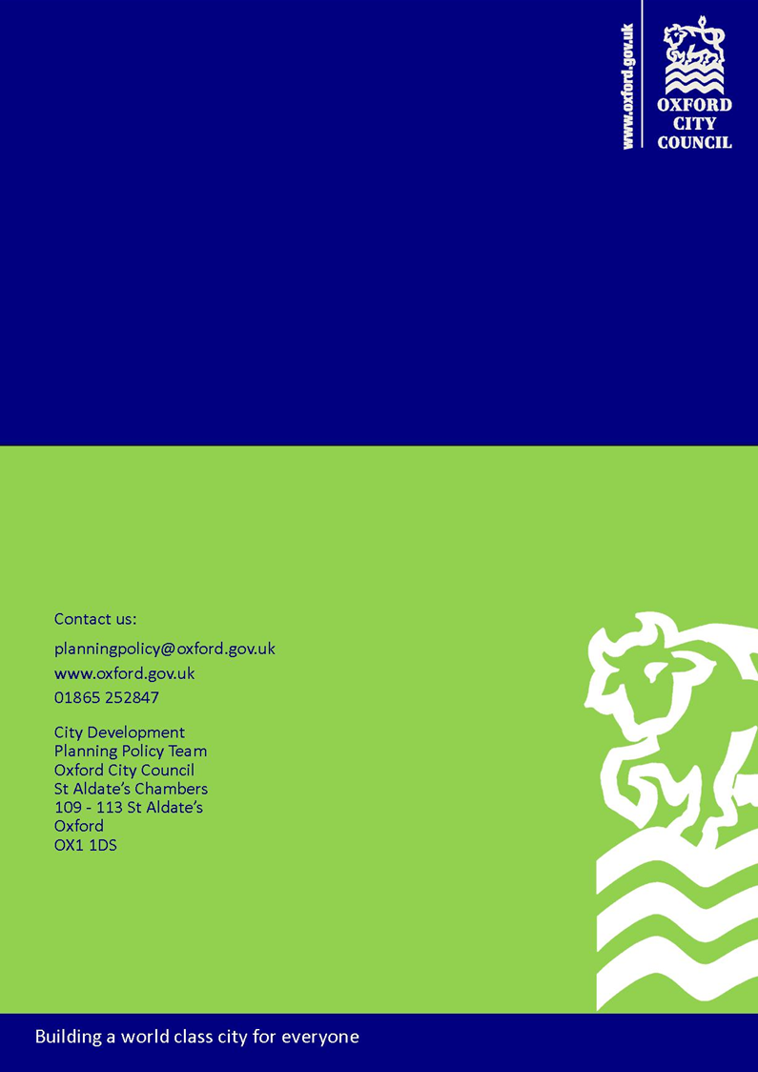

Roger Dudman Way Review, Main Report and Executive Summary available online: http://mycouncil.oxford.gov.uk/documents/s16562/RDW%20INDEPENDENT%20REVIEW%20FINAL%20REPORT%20140107%2017th%20Jan.pdf
The current minimum requirements for consultation on local development plan documents and supplementary planning documents are set out in The Town and Country Planning (Local Planning) (England) Regulations 2012. The minimum requirements for consultation on Planning Applications are set out in the Town and Country Planning (Development Management Procedure) Order 2010.
At the time of writing this is known as the ‘Regulation 18’ stage in reference to Regulation 18 of The Town and Country Planning (Local Planning) (England) Regulations 2012.
At the time of writing this is known as the ‘Regulation 19 stage’ in reference to Regulation 19 of The Town and Country Planning (Local Planning) (England) Regulations 2012.
At the time of writing, this is known as the ‘Regulation 24 stage’, in reference to Regulation 24 of The Town and Country Planning (Local Planning) (England) Regulations 2012.
An up-to-date list of deposit points (where paper copies of consultation documents will be made available) and their opening times is provided on the City Council website.
At the time of writing, this is The Neighbourhood Planning (General) Regulations 2012.
Neighbourhood planning groups are community groups that are designated to take forward neighbourhood planning in areas without parish councils. Where a Parish Council exists for local area, then they are the only group allowed to progress a neighbourhood plan in their area. It is the role of the City Council to agree who should be the neighbourhood planning group for the neighbourhood areas without a parish council.
We have produced a help sheet that provides an overview of the roles of the neighbourhood planning group and the City Council at each stage of the Neighbourhood Plan Process.
At the time of writing this is a minimum of six weeks, as set out in The Neighbourhood Planning (General) Regulations 2012.
At the time of writing this is the Neighbourhood Planning (Referendum) Regulations 2012 (as amended by the Neighbourhood Planning (Referendum) (Amendment) Regulations 2013 and 2014) and the Neighbourhood Planning (Prescribed Dates) Regulations 2012.
At the time of writing, major applications are defined by Article 2 of the Town and Country Planning (Development Management Procedure (England) Order 2015.
We have produced help sheets on the Council website which set out examples of good practice in pre-application engagement
A planning performance agreement sets timescales for actions by the City Council and applicants at the pre-application and application stage. (See the Planning Practice Guidance for further information.)
The publicity requirements for different types of planning application are set by the Government in the Planning Practice Guidance.
Qualifying planning applications are currently advertised in the Oxford Times newspaper.
A summary of statutory consultees for planning applications is provided in the Planning Practice Guidance.
Section 70(2) of the Town and Country Planning Act 1990 and section 38(6) of the Planning and Compulsory Purchase Act 2004.
The Planning Inspectorate guide to Planning Appeals is available online via the Planning Portal website: www.planningportal.gov.uk
At the time of writing, these requirements are set out in Regulation 18 of The Town and Country Planning (Local Planning) (England) Regulations 2012.
At the time of writing, these requirements are set out in Regulation 19 of The Town and Country Planning (Local Planning) (England) Regulations 2012
At the time of writing, these requirements are set out in Regulation 22 of The Town and Country Planning (Local Planning) (England) Regulations 2012.
At the time of writing, these requirements are set out in Regulation 26 of The Town and Country Planning (Local Planning) (England) Regulations 2012.
At the time of writing, these requirements are set out in Regulation 12/13 of the Town and Country Planning (Local Planning) (England) Regulations 2012
At the time of writing, these requirements are set out in Regulation 12/13 of the Town and Country Planning (Local Planning) (England) Regulations 2012
There may be additional fee for this service. Further details about pre-application advice are provided on the City Council website.

